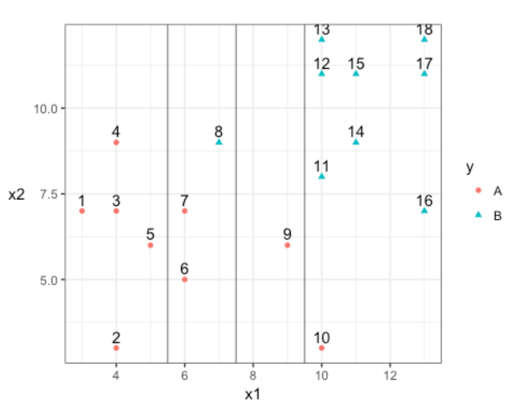

1. Construct the decision rule according to this classification boundary. How would you classify a new observation that has x1=6x1=6 and x2=10x2=10?

Decision Rule:  
X1<7.5=A  
X1>7.5=B

X1=6 will be A and X2=10 will be B.

1. What size is the margin here?

2

1. Which observations receive a penalty? Which observations are the support vectors?

6,7,9,10 and 8 receive penalty and are the support vectors as well.

1. What is the total penalty here?

6,7->0.25

9<-1.75

8->1.25

10<-2.25

Total = 5.75

1. Can I choose a bigger margin if my total allowable penalty is 6?

Yes

1. Are the data separable? If so, what are the support vectors?

Not possible to make the data completely separable.